Batch: E2 Roll No.: 16010123325

Experiment No. 2

Title: Linear Algebra - Solving System of Linear Equations using R
Aim : To explore methods for solving systems of linear equations using R, including visualization, and understanding their application in data science.

Course Outcome:

CO2

Books/ Journals/ Websites referred:

- The Comprehensive R Archive Network
- Posit

Resources used:

Theory:

Linear algebra is fundamental in data science for operations like feature transformations, dimensionality reduction (e.g., PCA), solving optimization problems (e.g., regression), and working with graph structures.

Procedure and Implementation in R:
A system of linear equations can be represented in matrix form as:

AX = B

Where:

- A is the coefficient matrix.
- X is the column vector of variables.
- B is the column vector of constants.

The solution to this system involves finding X such that the equation holds true. In R, we can solve such systems using the following methods:
- Solving Using Gauss-Jordan Elimination : Perform row operations manually in R to transform A into its reduced row-echelon form.
- Direct Inversion: Compute −1 , where −1 is the inverse of matrix A.
𝑋 = 𝐴 𝐵 𝐴
- Built-in Functions: R provides the solve() function to solve AX = B directly.

Part 1: A system of two linear equations
- Define the System of Linear Equations:

Solve:
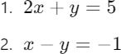

- Represent in Matrix Form:

Define A as the coefficient matrix and B as the constant matrix:

𝐴 = [2 1 1 − 1 ]
𝐵 = [5 − 1 ]
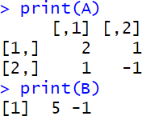

Create augmented matrix:

[2 1 5 1 − 1 − 1 ]

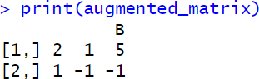

- Check whether there is a unique solution
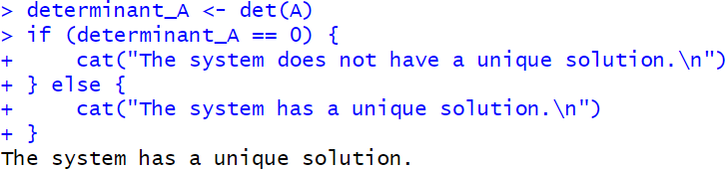

- Solve using Gauss Jordan elimination
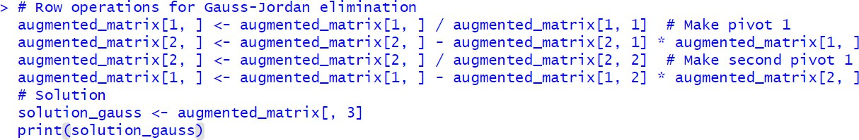

- Solve using inbuilt solve() method
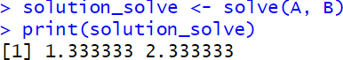

- Inversion −1
𝑋 = 𝐴 𝐵
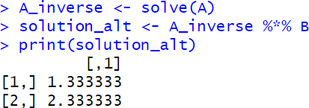

- Visualization
  - Define the system of equations 2x + y = 5; y = 5 - 2x
x - y = -1; y = x + 1

  - Generate x values
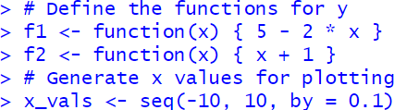

  - Plot the equations and solution
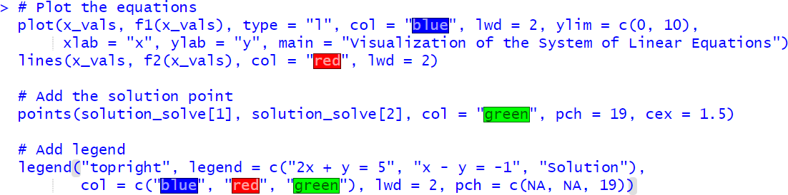

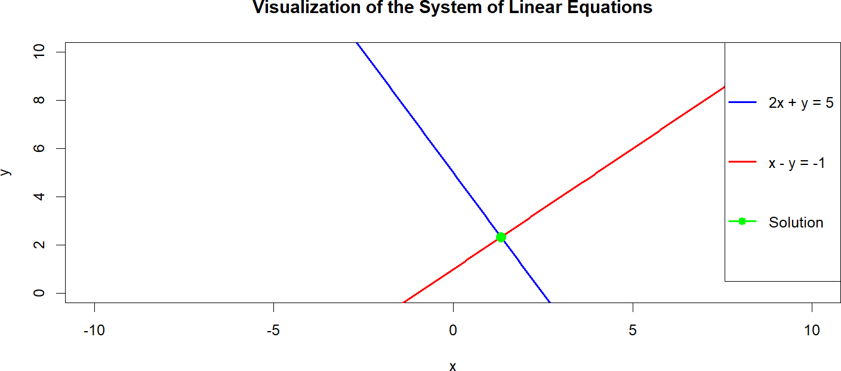

Part 2: A system of three linear equations
- Define the System of Linear Equations: Solve:

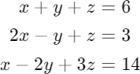

- Represent in Matrix Form:

Define A as the coefficient matrix and B as the constant matrix:

𝐴 = [1 1 1 2 − 1 1 1 − 2 3 ] 𝐵 = [6 3 14 ]
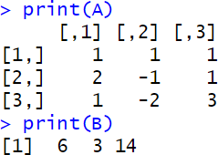

Create augmented matrix:

[1 1 1 6 2 − 1 1 3 1 − 2 3 14 ]
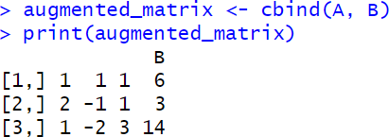

- Check whether there is a unique solution

- Solve using Gauss Jordan elimination

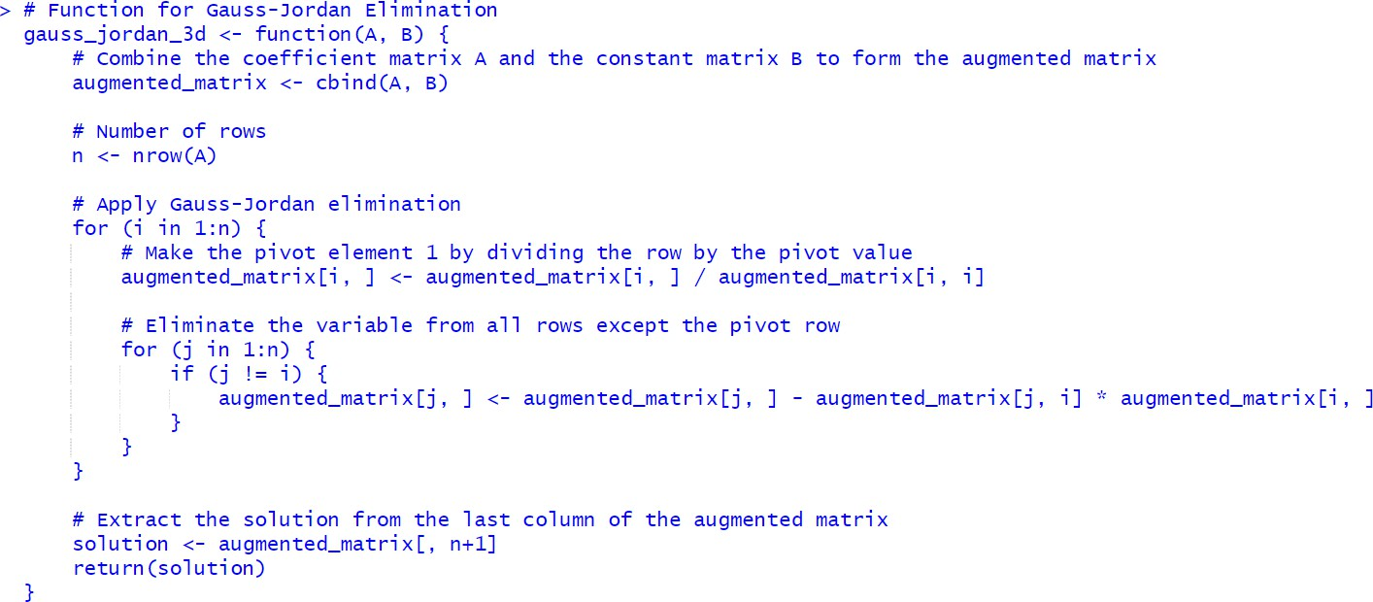
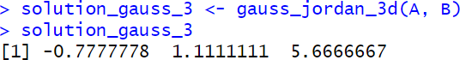

- Solve using inbuilt solve() method
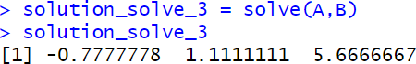

- Inversion
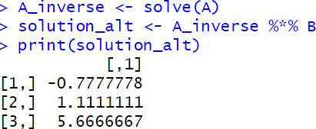

- Visualization

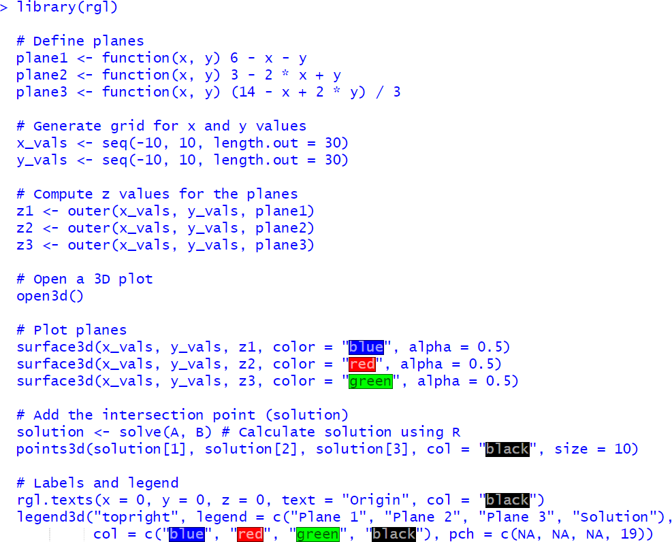

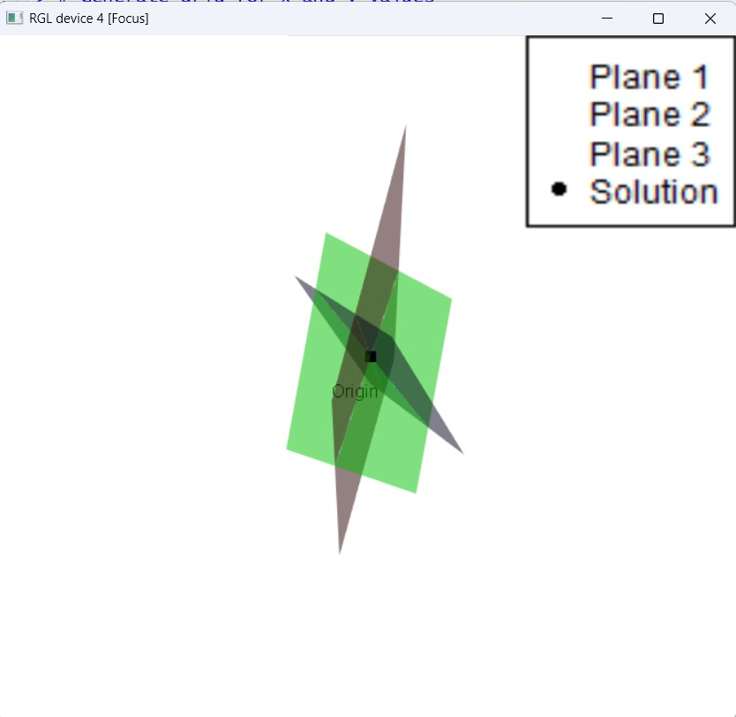

Students have to generate a system of 2 linear equations and a system of 3 linear equations with random coefficients and then perform the above steps on them.
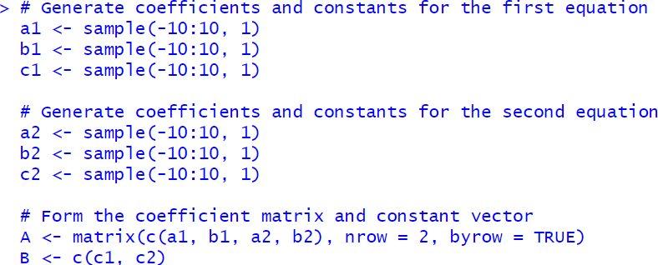

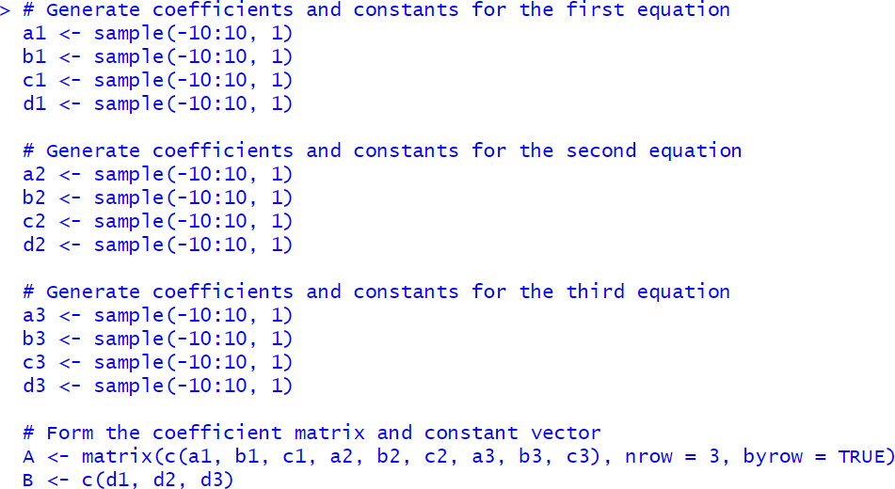

Performance in Lab:
Part 1: A system of two linear equations
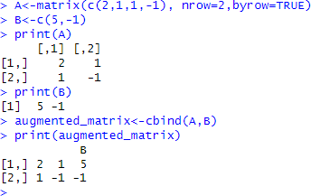
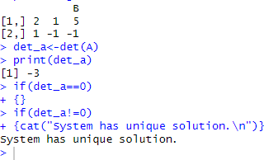

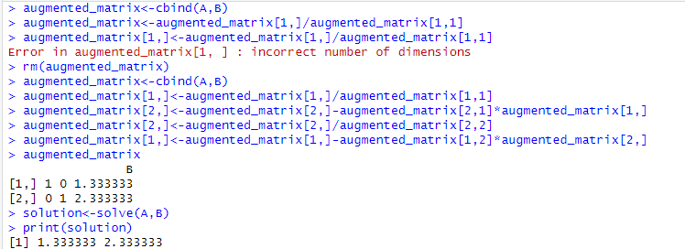
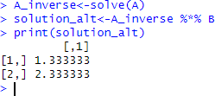
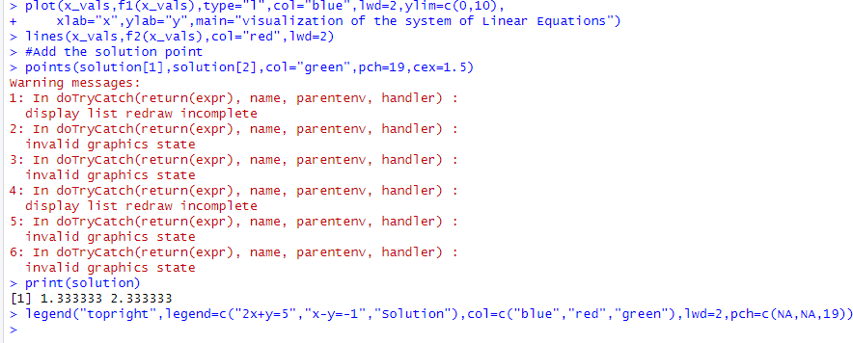

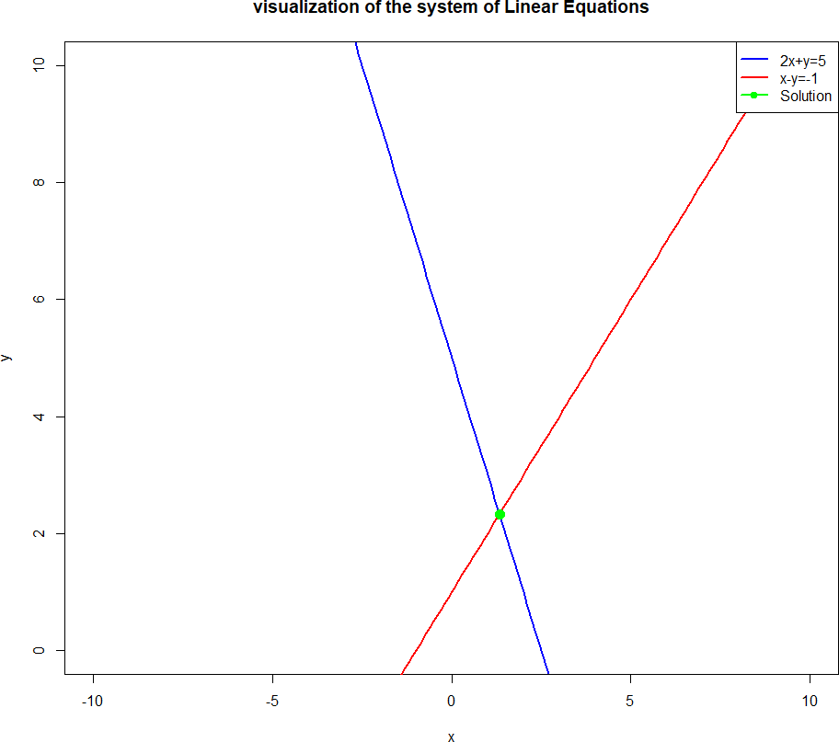

Part 2: A system of three linear equations

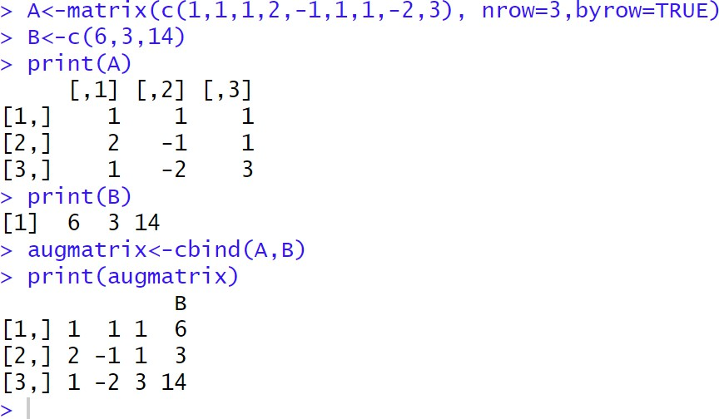
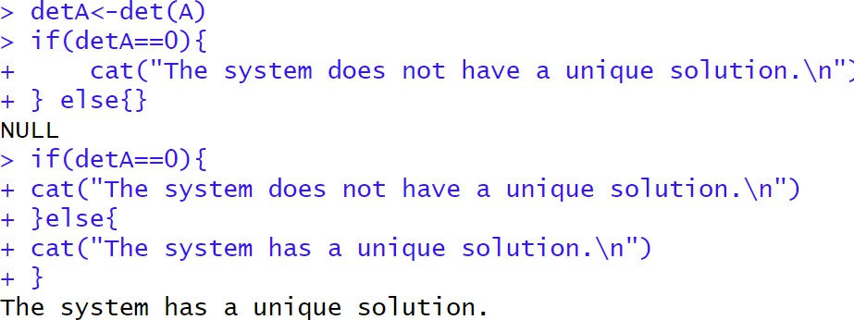

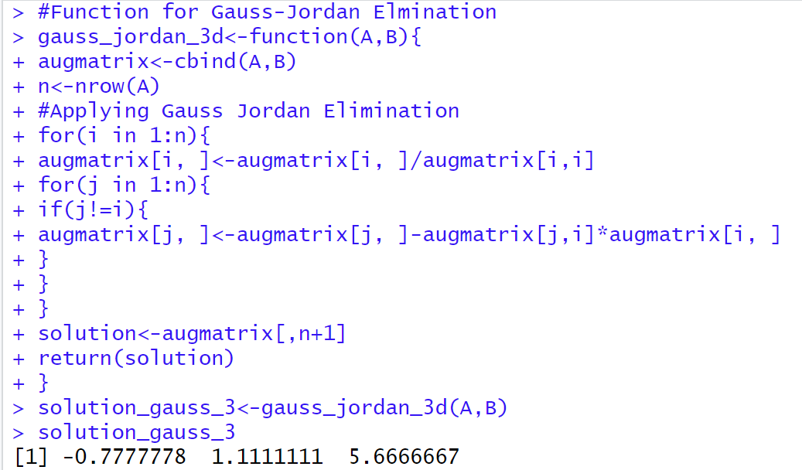
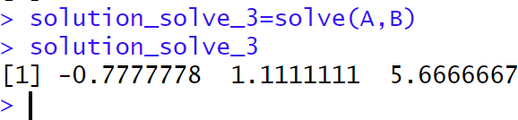

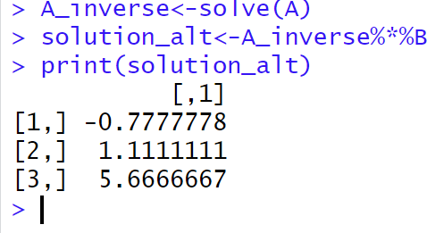

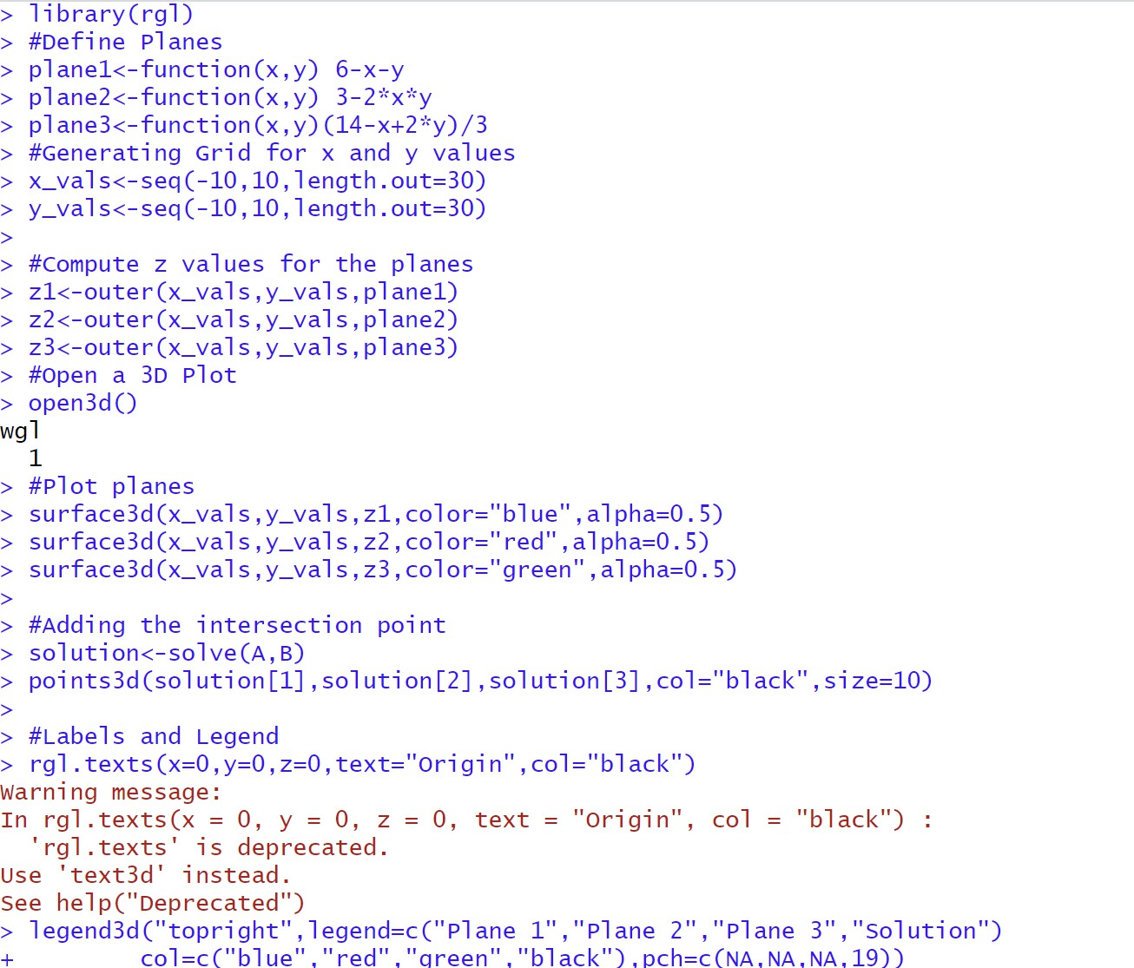

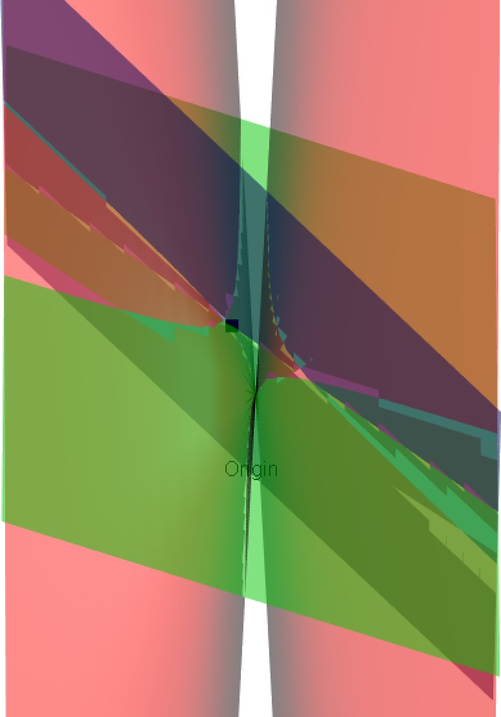

Conclusion:

Solving matrix equations in R and visualizing the solutions through plotting provides a clear understanding of linear relationships and solution spaces.
Post-lab questions:

- Why might certain systems of equations have no solution, a unique solution, or infinitely many solutions?
Ans:

No Solution Scenarios:
- Inconsistent equations
- Parallel lines with different y-intercepts
- Contradictory constraints
- Mathematically represented by 0 = non-zero constant
- Example: 2x + 3y = 10 and 2x + 3y = 15

Unique Solution Scenarios:
- Lines intersect at exactly one point
- Independent equations with distinct constraints
- Mathematically represented by unique (x,y) coordinates
- Precise balance of coefficients
- Example: x + y = 5 and 2x - y = 3

Infinitely Many Solutions:
- Completely overlapping lines
- Identical equation representations
- Mathematically represented by 0 = 0
- Equivalent equations with same slope/intercept
- Example: 2x + y = 6 and 4x + 2y = 12

Determining Factors:
- Coefficient relationships
- Rank of augmented matrix
- Linear independence
- Geometric interpretation of equations
- Computational method of solving (elimination, substitution)

Mathematical Conditions:
- Consistent systems: At least one solution
- Dependent equations: Infinite solutions
- Independent equations: Unique solution

Visualization:
- Graphical representation shows intersection points
- Linear algebra techniques reveal solution characteristics

- Describe at least three real-world data science problems in detail where solving systems of linear equations is crucial.
Ans:
Three Detailed Data Science Problems Using Linear Equation Systems:
- Economic Forecasting Model
- Objective: Predict economic indicators
- Linear Equations Role:
  - Multiple regression analysis
  - Modeling relationships between variables
  - Estimating coefficients
- Variables:
  - GDP growth
  - Inflation rates
  - Unemployment
- Solving Technique:
  - Least squares regression
  - Matrix-based coefficient estimation
- Practical Impact:
  - Policy decision making
  - Investment strategy development
- Supply Chain Optimization
- Objective: Resource allocation optimization
- Linear Equations Applications:
  - Constraint modeling
  - Production capacity planning
  - Minimizing transportation costs
- Key Variables:
  - Production volumes
  - Shipping routes
  - Inventory levels
- Solving Techniques:
  - Linear programming
  - Simplex method
  - Matrix transformations
- Business Outcomes:
  - Cost reduction
  - Efficiency improvement
  - Inventory management
- Machine Learning Feature Selection
- Objective: Identifying most significant predictors
- Linear Equations Approach:
  - Regression coefficient analysis
  - Multivariate feature weighting
  - Dimensionality reduction
- Techniques:
  - Ordinary least squares
  - Ridge regression
  - Lasso regression
- Implementation:
  - Solving high-dimensional equation systems
  - Identifying feature importance
- Applications:
  - Predictive modeling
  - Customer behavior prediction
  - Risk assessment

- Investigate what happens when you attempt to invert a singular matrix using solve(). How does R handle this scenario?
Ans:
Matrix Inversion with Singular Matrices in R:
Singular Matrix Characteristics:
- Determinant = 0
- Non-invertible
- Linear dependencies exist
- Rank < full matrix dimension
R's solve() Function Behavior:
- Throws error when matrix is singular
- Generates warning/exception
- Prevents computational breakdown
Error Handling Mechanisms:
- Generates "system is computationally singular" message
- Stops matrix inversion process
- Prevents invalid mathematical operations
Alternative Approaches:
- Pseudoinverse Method
- Uses MASS package
- pinv() function
- Approximates inverse
- Handles near-singular matrices
- Regularization Techniques
- Add small constant to diagonal
- Improves matrix conditioning
- Reduces numerical instability
- Decomposition Methods
- Singular Value Decomposition (SVD)
- Eigenvalue decomposition
- Identifies matrix structural issues

- What are eigen values and eigen vectors? Describe at least three real-world data science problems in detail where eigen values and eigen vectors can be applied.

Ans:
Definition:
- Eigenvalues: Scalar values representing matrix's scaling factor
- Eigenvectors: Corresponding vectors unchanged in direction
- Represent fundamental linear transformation characteristics
Mathematical Representation:
- Av = λv
- A: Original matrix
- v: Eigenvector
- λ: Corresponding eigenvalue
Three Real-World Applications:
- Principal Component Analysis (PCA)
- Dimensionality Reduction
- Feature Extraction
- Key Steps:
  - Identify principal components
  - Capture maximum variance
  - Compress high-dimensional data
- Applications:
  - Image recognition
  - Face detection
  - Medical imaging analysis
- Recommender Systems
- User Preference Modeling
- Latent Feature Identification
- Techniques:
  - Matrix factorization
  - Collaborative filtering
  - Eigenvalue decomposition
- Use Cases:
  - Netflix recommendation engine
  - E-commerce product suggestions
  - Personalized content platforms
- Network Analysis
- Social Network Characterization
- Centrality Measurement
- Applications:
  - Identifying influential nodes
  - Understanding network structure
  - Analyzing communication patterns
- Computational Techniques:
  - PageRank algorithm
  - Graph spectral analysis
  - Community detection
Computational Characteristics:
- Capture system's fundamental dynamics
- Reveal underlying structural properties
- Provide dimensionality insights
Mathematical Properties:
- Invariant under linear transformations
- Represent system's core characteristics
- Enable complex data interpretation
Visualization Techniques:
- Spectral decomposition
- Geometric interpretation
- Dimensional mapping

